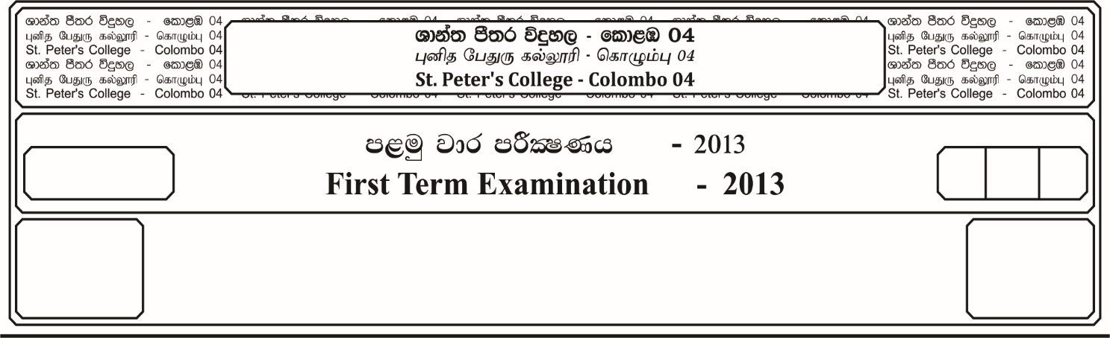

12 fY%aKsh

GRADE 12

E

$02$ meh

$02$ Hour

I

**udisl jdr mÍCIKh - 2023**

**Monthly Test - 2023**

ixhqla; .Ks;h

**COMBINED MATHEMATICS**

10

* **Answer four questions only.**

01. a). Express as rational number.

i). **0 . 1 $\dot{6}$**

ii). **0 . 1 $\dot{2}$ $×$ 0 . $\dot{3}$**

b). Rationalize the denominator.

i). $\frac{\sqrt{3} - \sqrt{2}}{\sqrt{3} + \sqrt{2}}$ ii). $\frac{3}{1 - \sqrt{2} + \sqrt{3}}$

c). Simplify,

i). $\frac{a^{2} - b^{2}}{a - b}$ **- $\frac{a^{3} - b^{3}}{a^{2} + b^{2}}$ + $\frac{b - a}{b^{2} - a^{2}}$**

ii). $\frac{1}{\left(a - b\right) (a - c)}$ **+ $\frac{1}{\left(b - c\right) (b - a)}$ + $\frac{1}{\left(c - a\right) (c - b)}$**

d). If $\frac{x}{b - c}$ $=$ $\frac{y}{c - a}$ $=$ $\frac{z}{a - b}$ then show that,

02. a). Solve the equation,

$x-$ $\sqrt{x + 1}$ $=5$

b). Solve the equation,

$\sqrt[3]{x^{2}}$**– $\sqrt[3]{x}$– 6 $=0$**

c). Solve the simultaneous equations.

**and**

03. a). The function f(x) is defined as,

$f\left(x\right)=$ $\frac{x - 1}{x + 3}$**+ 2 , $x ≠ -3$**

Find,

i). the domain and range of the function.

ii). $f (-2)$

iii). $f^{-1} (2)$

b). The functions $f(x)$ and $g(x)$ defined as,

$f\left(x\right)=$ $\frac{1}{x}$ and $g\left(x\right) =$ $(x + 5)$ Find,

i). $fg(x)$ ii). $gf(x)$ iii). $f^{-1}\left(x\right)$ iv). $gg(x)$

c). The functions $f$ and $g$ are defined by

$f :x → 5x + 4$

$g :x → 6x + k$, Where $x∈R$ and $k$ is a constant.

i). Find the value of $k$ for which $fg = gf$

ii). Prove that $fff :x → 125 x + 124$

**14 cm**

**O**

**14 cm**

**240**

**A**

**B**

04. a). is the center of the circle of radius $14 cm$. Find,

i). The length of major arc $AB$

ii). The area of shaded region.

iii). The perimeter of the major sector.

**A**

**D**

**C**

**B**

**E**

**14 cm**

b). $ABCD$ is a square of the side $14 cm$.

Find,

i). Area of $ABD$ triangle.

ii). Area of $ABD$ sector.

iii). Area of the shaded region

iv). Perimeter of the shaded region.

05. a). Find the values of the following.

i). $2 {Sin}^{2} 30° + 2 {Cos}^{2} 60°$

ii). $tan$ $π/4$**- $tan$ $π/6$ + $Cot$ $\frac{2π}{3}$**

iii). $\frac{2 Sin 90° - 3 Cos 90°}{3 Cos 90° + 2 Sin 90°}$ **+ $\frac{2 × Sin 60° - Cos 60°}{\sqrt{3} × Sin 60° + 2 Cos 30°}$**

iv). $\frac{Sin 75°}{Cos 15°}$ $×$ $\frac{Cos 89}{Sin 01}$

b). If $Sin θ =$ $\frac{5}{13}$ and $θ$ in the second quadrant, then find the values of the following.

i). $Cos θ$

ii). $\frac{Sin θ + Cos θ}{tan θ}$

iii). Simplify, $\frac{Cos \left(90 + θ\right) . Sec \left(-θ\right) . tan (180- θ)}{Sec \left(360- θ\right) . Sin \left(180 + θ\right) . Cot (90-θ)}$

iv). Simplify, $\frac{Cosec \left(π + θ\right) . Cos (π/2 - θ)}{Sin \left(\frac{3 π}{2} + θ\right)}$

c). Prove that,

i). $\frac{1 + Sin θ}{Cos θ} + \frac{Cos θ}{1 + Sin θ} = 2 Sec θ$

ii). $\sqrt{\frac{1 + Cos θ}{1 - Cos θ}} = Cot θ + Cosec θ$

iii). $Cos 2 θ$ $=$ $\frac{1 - \tan^{2} θ}{1 + \tan^{2} θ}$